

CSA15 – CLOUD COMPUTING AND BIG DATA ANALYTICS

ASSIGNMENT 1 – CO1

Design, Analyse and Validate a Cloud-Based Solution for Migrating a Legacy University Management System
CO1: Apply cloud computing technologies including hardware–software evolution, virtualization, web services, and service models to develop cloud-based solutions.

Field | Details | Field | Details
Student Name | Karnesh V K | Register Number | 192524296
Department / Section | B. TECH AI&DS | Academic Year / Semester
Faculty Name | DR.Latha.R | Nature of Assignment | Individual
Duration | 1 Week | Total Marks | 50
Submission Date |  | Evaluation Date

MARK SHEET (Rubric-based evaluation)
Task | Title | Max | Awarded | Evidence / evaluation focus
1 | Introduce Cloud Computing | 3 |  | Definition; characteristics;  deployment models; scenario mapping
2 | Trace Evolution and Hardware Evolution | 3 |  | Timeline; hardware evolution; relevance to university
3 | Analyse Internet Software Evolution | 3 |  | Web/software evolution; SOA; APIs; scenario relevance
4 | Apply Server Virtualization | 5 |  | Hypervisor types; VM/container comparison; consolidation; limitations
5 | Apply Web Services | 4 |  | SOA and SOAP/REST; three university APIs; request/response examples
6 | Analyse IaaS, PaaS and SaaS | 5 |  | Responsibility layers; five-application mapping; comparison; providers
7 | Examine XaaS | 3 |  | Four or more variants; two justified choices; provider risks
8 | Design Cloud Solution | 5 |  | Labelled diagram;

 | Architecture |  |  | deployment/service models; scaling;  security; DR
9 | Hands-on Implementation and Documentation | 4 |  | Running VM/container; PaaS/SaaS; tests; actual screenshots
10 | Evaluate and Recommend Final Solution | 7 |  | Three-way comparison; 3-year costs; risks; phased roadmap
11 | Day-4 Design Challenge | 8 |  | Impact; evaluation; adaptation; evidence-based defence
 | TOTAL | 50 |  | Percentage :

EVIDENCE VERIFICATION CHECKLIST

Tasks | Evidence expected | Status (✓  / P / ✗ ) | Evaluator note
1–3 | Conceptual explanations, comparisons and relevant illustrations | ✓ | Explanations and relevant scenario mapping documented
4 | Virtualization calculations with  stated assumptions and peak-load caution | ✓ | Calculations present; practical capacity validation  recommended
5–7 | API examples, service responsibility table and justified XaaS choices | ✓ | Required conceptual evidence documented
8 | Labelled architecture diagram,  caption below figure and component justification | ✓ | Architecture documented;  sizing assumptions need testing
9 | Actual code, environment details, execution logs, API outputs and screenshots | P | Procedures provided; actual execution evidence not  established
10 | Cost assumptions, 3-year totals, risk controls and migration roadmap | ✓ | Estimates and rationale documented
11 | Day-4 changes, 10× load strategy, 99.9% target and 40-college isolation | ✓ | Design analysis documented; practical validation pending

IMPLEMENTATION EVIDENCE CHAIN

Evidence item | Status | Observation
Source code | ✓ | Flask REST API and Dockerfile provided in the proposed implementation
Virtualization | P | Docker container configuration documented; running-container evidence required
PaaS or SaaS | P | Managed web-service deployment procedure described; live deployment not verified
Functional test | P | Expected HTTP 200 response and JSON output documented; actual output required

Failure case | P | HTTP 404 test case documented; actual execution record required
Screenshots | P | Screenshot requirements identified; authentic screenshots need verification
Reproducibility | ✓ | Build commands, run commands, endpoints and expected results specified

OVERALL REMARKS

Student Signature | Faculty Signature | Program Director

MANDATORY SUBMISSION EVIDENCE CHECK
✓ = Present in documented answer; P = Partly present; ✗ = Missing / not satisfied

Task | Evidence expected | Status | Evaluator note
1 | Cloud definition, characteristics, deployment models and scenario mapping | ✓ | All conceptual requirements covered
2 | Evolution timeline, hardware  development and university relevance | ✓ | Well explained with relevant examples
3 | Internet software evolution, SOA and APIs | ✓ | Clear explanation and scenario relevance
4 | Hypervisors, VM/container  comparison and consolidation calculations | ✓ | Calculations included; peak-load limitations discussed
5 | SOAP/REST comparison and three university APIs | ✓ | API methods and request/response examples documented
6 | IaaS/PaaS/SaaS responsibility layers and application mapping | ✓ | All five applications categorized with justification
7 | XaaS variants and two justified selections | ✓ | Six variants explained; DBaaS and DRaaS recommended
8 | Labelled architecture, scaling, security and disaster recovery | ✓ | Design and component justifications documented
9 | Working container, PaaS/SaaS deployment, actual tests and screenshots | P | Code and procedures provided; actual  execution evidence requires verification
10 | Three-year cost comparison, risks and migration roadmap | ✓ | Cost assumptions, calculations and recommendations included
11 | Impact analysis, 10× load, 99.9% availability and tenant isolation | ✓ | Changed requirements evaluated; load-test evidence recommended

IMPLEMENTATION EVIDENCE CHAIN

Evidence item | Status | Observation
Source code | ✓ | Python Flask REST API and Dockerfile documented
Virtualization | P | Docker build and run procedures provided; execution screenshot required
PaaS or SaaS | P | Cloud deployment steps described; actual deployment confirmation required
Functional test | P | HTTP 200 and expected JSON response documented; actual

 |  | test output required
Failure case | P | HTTP 404 test case included; execution evidence required
Screenshots | P | Required screenshots identified but authenticity and completeness not verified
Reproducibility | ✓ | Installation, configuration, commands and testing steps documented
Interpretation | ✓ | Technical outcomes and implementation limitations explained
Code and report consistency | ✓ | Proposed API, Docker configuration and testing procedure are aligned

SUBMISSION CHECKLIST (Not Separately Marked)

Requirement | Status
All 11 tasks answered | ☒ Yes ☐ Partly ☐ No
Cloud concepts and comparisons explained | ☒ Yes ☐ Partly ☐ No
Virtualization calculations included | ☒ Yes ☐ Partly ☐ No
API examples and service models explained | ☒ Yes ☐ Partly ☐ No
Cloud architecture diagram included | ☒ Yes ☐ Partly ☐ No
Implementation and testing evidence provided | - Yes ☒ Partly ☐ No
Three-year cost analysis and roadmap included | ☒ Yes ☐ Partly ☐ No
Day-4 design challenge completed | ☒ Yes ☐ Partly ☐ No
Figures and screenshots included | - Yes ☒ Partly ☐ No
Table and figure numbering correct | - Yes ☒ Partly ☐ No
Viva recommended | ☒ Yes ☐ No

CSA15 – Cloud Computing and Big Data Analytics

ASSIGNMENT 1
CO1: Apply cloud computing technologies including hardware–software evolution, virtualization, web services, and service models to develop cloud-based solutions.

Assignment Title: Design, Analyse and Validate a Cloud-Based Solution for Migrating a Legacy University Management System (Total Marks – 50)

Duration: 1 week

Scenario – Smart Campus Cloud Migration
A multi-campus university currently runs its Student Information System, Learning Management System, Library System, Exam Portal and Email on ageing physical servers in a single on-premise data centre. Each application has its own dedicated server, which stays idle for most of the year but fails to cope during admissions, result publication and online-exam weeks.
The university's current environment is:
- 12 physical servers, average CPU utilisation of about 15%, with peaks above 95% during admissions and exams
- Approximately 25,000 students and 2,000 staff across 4 campuses
- Applications built as large monolithic programs, with no public interfaces for mobile apps or partner colleges
- High capital expenditure, slow procurement (6–8 weeks per server) and no disaster recovery site
As a cloud consultant, you must study how computing evolved to the cloud model, and then design a cloud-based solution that uses virtualization, web services and an appropriate mix of service models (IaaS, PaaS, SaaS and XaaS) for the university. All recommendations must be justified in terms of cost, scalability, availability and manageability.

Design Challenge:
On Day 4, the university announces that it will launch a mobile app and open student-record and fee-payment services to 40 affiliated colleges. Expected load is 10 times the current peak, with a requirement of 99.9% availability and a limited operating budget. Re-evaluate your original design and decide whether it should be retained, modified or redesigned.

TASK 1 – Introduce Cloud Computing and Map It to the Scenario (3 Marks)

Design and Propose cloud computing model for the context of the university's problems.
- Definition of cloud computing and the five essential characteristics (on-demand self-service, broad network access, resource pooling, rapid elasticity, measured service)
- Deployment models (public, private, hybrid, community) and which one suits the university
- Three problems of the current on-premise setup and how each cloud characteristic addresses them
- Benefits and limitations of cloud adoption for the university

Evidence Expected
A clear explanation of cloud characteristics and deployment models, mapped to the university's actual problems.

TASK 2 – Trace the Evolution and Hardware Evolution (3 Marks)
Trace how computing infrastructure evolved to make cloud computing possible.
- A timeline from mainframes, minicomputers and PCs, to client–server, clusters, grid computing, utility computing and cloud
- Hardware evolution: multi-core processors, commodity servers, high-capacity storage, high-speed networking and data centres
- How each stage solved a limitation of the previous one
- Which stage the university's current system corresponds to, with reasons

Evidence Expected
A labelled timeline or diagram, with a justified explanation of how hardware advances enabled the cloud.

TASK 3 – Analyse Internet Software Evolution (3 Marks)
Explain how internet software evolved and why it supports cloud services.
- Evolution from static web pages to dynamic web, Web 2.0, SOA, mashups and cloud-hosted applications
- Role of browsers, HTTP, AJAX and APIs in delivering software over the internet
- Comparison between desktop software, client–server software and web-delivered software
- How this evolution affects the design of the university's applications

Evidence Expected
A comparative explanation of software evolution stages, linked to the university's application design.

TASK 4 – Apply Server Virtualization (5 Marks)
Apply server virtualization to consolidate the university's 12 physical servers.
- Explain how a hypervisor works, and distinguish Type-1 and Type-2 hypervisors, with examples
- Compare full virtualization, para-virtualization, OS-level virtualization (containers) and hardware-assisted virtualization
- Propose which applications should run as virtual machines and which as containers, with reasons
- Calculate the consolidation: with an average utilisation of 15% per server and a target host utilisation of 70%, estimate how many physical hosts are needed (show your assumptions and working)
- Discuss live migration, snapshots and resource over-commitment as benefits, and the risks of virtualization (noisy neighbour, hypervisor failure, security isolation)

Show your calculation. A final number without working will not receive full credit.

Evidence Expected
A justified virtualization plan with a worked consolidation calculation and discussion of benefits and risks.

TASK 5 – Apply Web Services (4 Marks)
Analyse web services to expose the university's functions to other systems.
- Overview of web services and their role in cloud and SOA
- Compare SOAP, WSDL, UDDI and RESTful services (HTTP methods, JSON/XML)
- Identify at least three university functions to expose as web services (for example, result lookup, fee payment, library search) and define the endpoint, method and sample request/response for each
- Justify whether SOAP or REST is more suitable for each function

Evidence Expected

A defined set of web services with sample request/response formats and a justified choice of SOAP or REST

TASK 6 – Analyse the Service Models: IaaS, PaaS and SaaS (5 Marks)
Analyse which service model fits each university application.
- Define IaaS, PaaS and SaaS, and show who manages which layer (hardware to application) in each model
- Categorise the five university applications (SIS, LMS, Library, Exam Portal, Email) into IaaS, PaaS or SaaS, with reasons
- Compare the models on control, cost, scalability, maintenance effort and vendor lock-in
- Give one real provider example for each model
Present your categorisation in a table, but explain the reasoning behind each
decision. A table alone is not sufficient.

Evidence Expected
A reasoned mapping of applications to service models, supported by a layer-wise responsibility comparison.

TASK 7 – Examine XaaS (3 Marks)
Examine the broader XaaS (Anything-as-a-Service) concept for the university.
- Explain XaaS and describe at least four variants (for example DaaS, BaaS/MBaaS, FaaS, DBaaS, Security-as-a-Service, Disaster-Recovery-as-a-Service)
- Select two XaaS offerings that would benefit the university, and justify them
- Discuss the risks of over-reliance on multiple 'as-a-Service' providers

Evidence Expected
An analysis of XaaS variants, with justified selection of two offerings for the university.

TASK 8 – Design the Cloud Solution Architecture (5 Marks)
Bloom's Level: Level 6 – Create | Action verbs: Design, Construct, Propose
Create a complete cloud architecture for the university by combining virtualization, web services and service models.
- An architecture diagram showing users, load balancer, web/application tier, database tier, storage, API layer and DR region

- The deployment model and the service model chosen for each component
- How elasticity (auto-scaling) will handle admissions and exam peaks
- Basic security and availability measures (access control, encryption, backup, multi-zone deployment)

Evidence Expected
A labelled architecture diagram with written justification for each component and design decision.

TASK 9 – Hands-on Implementation and Documentation (4 Marks) Implement a small proof-of-concept of your design using a free-tier cloud account or a local virtualization tool.
- Create a virtual machine or container (using AWS/Azure/GCP free tier, VirtualBox, or Docker) and host a simple web page or REST API for one university function
- Deploy a SaaS or PaaS component (for example a cloud-hosted database, a serverless function or a static site)
- Test the web service with a client (browser, Postman or curl) and record the output
- Provide screenshots, configuration steps and any issues faced

Evidence Expected
Annotated screenshots and clear, reproducible steps showing that the proof-of-concept works.

TASK 10 – Evaluate and Recommend the Final Solution (7 Marks)
Evaluate your design and recommend the final cloud solution for the university.
- Compare on-premise, IaaS-based and PaaS/SaaS-based options on cost (CapEx vs OpEx), scalability, availability, security and effort
- Estimate a simple 3-year cost comparison using stated assumptions
- Identify the main risks (vendor lock-in, data privacy, downtime, skills gap) and give mitigation steps
- Provide your final recommendation and a short migration roadmap (which application moves first, and why)

Your recommendation must be supported by the analysis in the previous tasks. Choosing a popular cloud provider without justification is not sufficient.

Evidence Expected
A technically justified recommendation, supported by a cost comparison, risk analysis and migration roadmap.

DAY-4 DESIGN CHALLENGE

TASK 11 – Re-evaluate and Adapt the Design (8 Marks)

Changed Requirement
The university will now launch a mobile app and open student-record and fee-payment services to 40 affiliated colleges. Expected load is 10 times the current peak, availability must be 99.9%, and the operating budget is limited.
Re-evaluate your original design in response to these changed conditions. You may:
RETAIN → MODIFY → or REDESIGN
your original solution.

Impact Analysis – 2 Marks
Discuss:
- What has changed from the original problem
- Which original assumptions (load, users, availability, cost) are affected
- Why the web services and APIs now become critical
- How multi-tenant access by 40 colleges affects security and isolation
Evidence Expected: A clear analysis of how the changed requirements affect the original cloud design.

Evaluation of the Original Design – 2 Marks
Discuss:
- Whether the chosen service models and virtualization plan can handle a 10x load
- Whether auto-scaling and the single-region deployment are sufficient for 99.9% availability (about 8.76 hours of downtime allowed per year)
- Whether cost remains acceptable under the new load
- Whether another service model or XaaS offering would give better overall results
Evidence Expected: A technically supported evaluation of the original design under the new conditions.

Adaptation or Redesign – 2 Marks
Discuss:
- Decide whether to retain, modify or redesign the solution
- Describe the revised architecture (for example API gateway, container orchestration, serverless components, multi-zone deployment or a hybrid model)
- Explain what changed in the service model mix and in the virtualization approach
- If you retain the original design, give sufficient technical justification for why no change is required
Evidence Expected: An appropriate design response to the changed requirement, with clear technical reasoning.

Evidence-Based Defence – 2 Marks
Discuss:
- Capacity and availability calculations
- Cost comparison between the original and the revised design
- Security and multi-tenancy considerations
- Trade-offs such as vendor lock-in, complexity and migration effort
Evidence Expected: A well-supported final decision that follows logically from the analysis.

MARK DISTRIBUTION

Task | Title | Bloom's Level | Marks
Task 1 | Cloud Computing – Introduction & Characteristics | L2 – Understand | 3
Task 2 | Evolution & Hardware Evolution | L2 – Understand | 3
Task 3 | Internet Software Evolution | L2 – Understand | 3
Task 4 | Server Virtualization | L3 – Apply | 5
Task 5 | Web Services | L3 – Apply | 4
Task 6 | Service Models: IaaS, PaaS, SaaS | L4 – Analyze | 5
Task 7 | XaaS | L4 – Analyze | 3
Task 8 | Design the Cloud Solution Architecture | L6 – Create | 5
Task 9 | Hands-on Implementation & Documentation | L3 – Apply | 4
Task 10 | Evaluate & Recommend the Final Solution | L5 – Evaluate | 7
 | Subtotal

Task 11 | Day-4 Design Challenge | L4 / L5 / L6 | 8
 | TOTAL |  | 50

TASK 1: Introduce Cloud Computing and Map It to the University Scenario
1.1 Introduction to Cloud Computing
Cloud computing is a technology that provides computing resources such as servers, storage, databases, networking, and software through the internet. It allows organizations to use computing resources whenever required without purchasing and maintaining all the physical infrastructure themselves.
For the university, cloud computing can provide a common platform for the Student Information System, Learning Management System, Library System, Examination Portal, and Email System. It can improve resource utilization, reduce infrastructure management work, and provide reliable access across four campuses.
1.2 Five Essential Characteristics of Cloud Computing
1. On-Demand Self-Service
Users can provision computing resources whenever required without waiting for manual intervention from the service provider.
University example: Additional virtual servers can be created during admission periods to support increased student traffic.
2. Broad Network Access
Cloud services can be accessed over a network using devices such as laptops, smartphones, and tablets.
University example: Students from all four campuses can access attendance records, examination results, and course information through a common portal.
3. Resource Pooling
The cloud provider uses a shared pool of computing resources to serve multiple customers while maintaining appropriate isolation.
University example: Different university applications can share cloud infrastructure instead of requiring a separate physical server for every application.
4. Rapid Elasticity
Computing resources can be increased or decreased according to workload requirements.
University example: Additional application instances can be started during online examinations and result publication, then reduced when traffic decreases.
5. Measured Service
Cloud resource consumption is monitored and measured so that usage and costs can be tracked.
University example: The university can monitor CPU usage, storage consumption, and network traffic to identify unnecessary expenditure.
1.3 Cloud Deployment Models
Model | Description | Application to the university
Public cloud | Services run on infrastructure provided by a third-party cloud provider. | Hosting the student portal and scalable web applications.
Private cloud | Infrastructure is dedicated to a single organization. | Running applications that require dedicated infrastructure or additional control.
Hybrid cloud | Combines private infrastructure with public cloud services. | Retaining selected legacy systems while using public cloud services for scalable applications.
Community cloud | Infrastructure is shared by organizations with common requirements. | Supporting selected services shared by participating educational institutions.
Recommended model: Hybrid cloud.
A hybrid-cloud approach can help the university migrate gradually without moving every legacy application at once. It can retain selected systems in the existing environment while introducing public cloud services for applications that need greater scalability.
The final decision should depend on security requirements, application compatibility, total cost, and the university's data-management policies.
1.4 Problems in the Existing System and Cloud-Based Solutions
Existing problem | Proposed cloud solution | Expected benefit
Twelve physical servers operate at approximately 15% average CPU utilization. | Consolidate suitable workloads using virtualization. | Better resource utilization and potentially lower hardware costs.
CPU utilization exceeds 95% during admissions and examinations. | Introduce elastic application capacity and load balancing. | Better handling of peak demand.
Server procurement takes 6–8 weeks. | Use automated cloud resource provisioning. | Faster deployment of computing resources.
Applications have no public interfaces. | Develop secure APIs. | Easier integration with mobile applications and external institutions.
No disaster recovery site exists. | Establish protected backups and a recovery environment. | Improved ability to restore critical services after failures.
1.5 Benefits of Cloud Adoption
- Reduces the need to purchase additional physical servers.
- Improves utilization through workload consolidation.
- Provides flexible capacity for admission and examination periods.
- Enables access to university services across multiple campuses.
- Supports backup, monitoring, and disaster recovery.
- Reduces delays in provisioning infrastructure.
- Makes it easier to introduce new digital services.
1.6 Limitations of Cloud Adoption
- Requires reliable network connectivity.
- Creates potential dependence on cloud providers.
- Requires careful protection of confidential student information.
- Can result in unexpected costs if resources are not monitored.
- May require modifications to legacy applications.
- Requires appropriate technical skills and operational procedures.
Conclusion: Cloud computing is suitable for the university because it can improve scalability, infrastructure utilization, accessibility, and recovery capabilities. A phased hybrid-cloud migration provides a practical starting point.
TASK 2: Trace the Evolution and Hardware Evolution of Computing
2.1 Evolution of Computing Infrastructure
Computing infrastructure has developed from centralized mainframes to distributed systems and cloud platforms. Each stage introduced improvements in accessibility, resource sharing, processing capacity, and management.
Mainframe Computing
Centralized processing for many users
Minicomputers and Personal Computers
More affordable and accessible computing
Client–Server Computing
Central servers provide services to connected clients
Cluster Computing
Connected computers work together
Grid Computing
Distributed resources cooperate across locations
Utility Computing
Computing resources are supplied as a service
Cloud Computing
On-demand resources, automation, elasticity and measured usage
Evolution of Computing Infrastructure
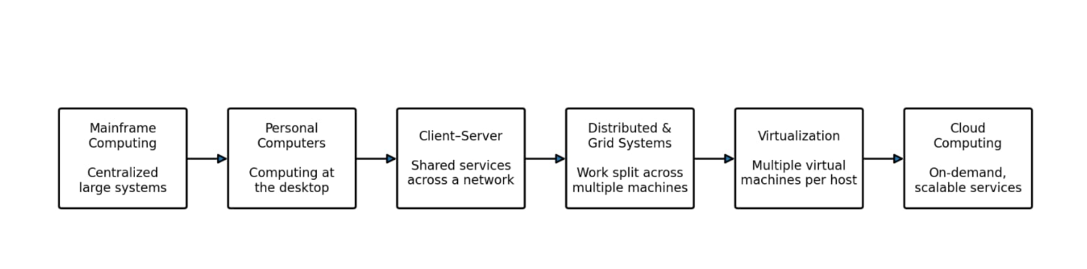
2.2 Main Stages of Evolution
1. Mainframe Computing
Mainframes provided centralized processing for many users. They were reliable but expensive and depended on centralized hardware.
2. Minicomputers and Personal Computers
Minicomputers made computing more accessible to smaller organizations. Personal computers later provided individual users with their own computing resources.
3. Client–Server Computing
Client–server systems separated user interfaces from central services. Clients requested data or operations, and servers processed those requests.
4. Cluster Computing
Clusters connected multiple computers so that they could cooperate on workloads. They improved processing capacity and could support high availability when designed appropriately.
5. Grid Computing
Grid computing combined distributed computing resources across different systems or locations to solve large computational problems.
6. Utility Computing
Utility computing introduced the idea of supplying computing capacity as a service, with costs associated with usage or allocated resources.
7. Cloud Computing
Cloud computing combines virtualization, distributed infrastructure, automation, networking, and service-based delivery. It enables users to provision computing resources rapidly and scale them according to demand.
2.3 Hardware Evolution
Multi-Core Processors: Modern processors contain multiple processing cores, enabling more work to be performed concurrently.
Commodity Servers: Standardized servers provide affordable processing capacity and can be combined into large infrastructure environments.
High-Capacity Storage: Modern storage technologies support large databases, documents, backups, and other digital information.
High-Speed Networking: Faster networks enable communication between users, servers, storage systems, and geographically distributed infrastructure.
Large Data Centres: Data centres combine servers, networking, power, cooling, and security systems to support large-scale computing.
Virtualization Support: Modern processors include hardware features that help hypervisors run virtual machines efficiently.
2.4 How Each Stage Improved the Previous Stage
Stage | Improvement
Mainframes | Enabled centralized computing for many users.
Minicomputers and PCs | Expanded access to computing and reduced dependence on a single central system.
Client–server | Separated client interfaces from shared application and database services.
Clusters | Combined multiple computers to improve capacity and resilience.
Grid computing | Coordinated resources across distributed locations.
Utility computing | Introduced service-based allocation and usage-oriented charging.
Cloud computing | Added on-demand provisioning, elasticity, automation, and managed service delivery.
2.5 Current Stage of the University
The university currently uses twelve physical servers in a single on-premises data centre. Each application has its own dedicated server, and the servers remain underutilized during normal periods but experience high CPU utilization during admissions and examinations.
This environment mainly represents traditional dedicated-server computing with a client–server application model.
The university has not fully adopted modern cloud capabilities because provisioning requires manual procurement, applications are monolithic, and there is no disaster recovery site.
It should progress toward cloud-enabled infrastructure by consolidating suitable workloads, introducing virtualization, developing APIs, and using managed services where appropriate.
Conclusion: Advances in processors, networking, storage, virtualization, and data-centre technology made cloud computing practical. These technologies provide a foundation for the university to improve efficiency and respond more quickly to changing demand.
TASK 3: Analyse the Evolution of Internet and Software Technologies
3.1 Evolution of Internet-Based Software
Software has progressed from locally installed programs and static websites to interactive web applications, service-based architectures, and cloud-hosted applications.
1. Static Websites
Static websites display predefined content using HTML and related files. Their content generally changes only when the files are updated.
Example: A university website displaying campus addresses and contact details.
2. Dynamic Websites
Dynamic websites generate content using application logic, databases, and user requests.
Example: A student portal displaying attendance and examination results for an authenticated user.
3. Interactive Web Applications
Interactive applications allow users to submit forms, retrieve information, and update records through browser interfaces.
Example: Students registering for courses through an online portal.
4. Service-Oriented Architecture
Service-Oriented Architecture (SOA) organizes application functionality into services that communicate through defined interfaces.
Example: The examination application obtains student details from the student information service.
5. Application Programming Interfaces
APIs allow software systems to exchange information through defined requests and responses.
Example: A mobile application retrieves course information through a university API.
6. Cloud-Based Applications
Cloud-based applications use cloud infrastructure or managed platforms to provide remote access, centralized updates, monitoring, and scalable capacity.
Example: A cloud-hosted Learning Management System.
3.2 Technologies Used in Web Applications
Technology | Function | University application
HTML | Defines the structure of web pages. | Student dashboard layout.
CSS | Controls page appearance and layout. | Designing a consistent university portal.
JavaScript | Adds client-side interaction. | Form validation and interactive dashboards.
HTTP/HTTPS | Transfers requests and responses between clients and servers. | Accessing the student portal securely using HTTPS.
AJAX | Enables asynchronous data requests without reloading an entire page. | Refreshing attendance information dynamically.
REST APIs | Expose application resources through HTTP-based interfaces. | Connecting mobile applications to university services.
JSON | Represents structured information in a lightweight format. | Returning examination results to a mobile application.
Databases | Store and retrieve structured information. | Maintaining student, course, and examination records.
3.3 Comparison of Application Types
Feature | Desktop application | Client–server application | Cloud-based web application
Access | Usually installed locally. | Requires a client and server connection. | Commonly accessed through a browser or mobile interface.
Maintenance | Updates may be required on individual devices. | Client and server components require maintenance. | Many updates can be managed centrally.
Scalability | Depends on local and connected resources. | Depends on server capacity and design. | Can use elastic cloud infrastructure.
Accessibility | Often limited to installed devices. | Depends on network access and client configuration. | Can support access from multiple campuses.
Example | Local examination processing tool. | Campus-hosted student database application. | Cloud-based student portal.
3.4 Role of SOA and APIs
SOA and APIs help the university integrate its separate applications without requiring every system to be completely rewritten.
For example, a student information service can provide authorized student details to the attendance, library, and examination systems.
A well-designed API should provide:
- A clear and documented interface.
- Authentication and authorization.
- Input validation.
- Appropriate error responses.
- Secure communication.
- Version management.
- Monitoring and audit logging.
APIs should not expose direct unrestricted database access. Each service must verify that a user is permitted to access the requested information.
3.5 Recommended Approach
The university should retain its existing applications during the initial migration where necessary, then gradually introduce APIs and modernize suitable components.
New services should use documented APIs and secure web technologies. This approach reduces the risk of a complete replacement while making future mobile and partner-college integration easier.
Conclusion: The evolution of internet and software technologies has made it possible to build connected, interactive, and scalable applications. The university can use web technologies, SOA, and APIs to integrate its legacy systems and improve access across campuses.
TASK 4: Apply Server Virtualization to the University Environment
4.1 Definition of Server Virtualization
Server virtualization is the process of creating multiple virtual servers on a physical machine. Each virtual machine can run its own operating system and applications while sharing the physical host's resources.
A hypervisor manages virtual machines and allocates CPU, memory, storage, and other resources.
For the university, virtualization can consolidate workloads currently running on twelve separate physical servers.
4.2 Types of Hypervisors
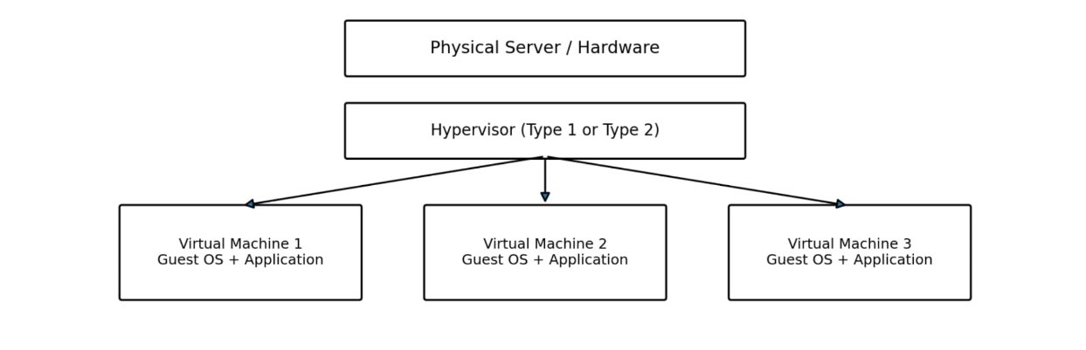
Type 1 Hypervisor
A Type 1 hypervisor runs directly on physical hardware.
Examples include VMware ESXi and Microsoft Hyper-V in its hypervisor role.
It is suitable for production environments because it supports centralized management of virtual machines and efficient use of server resources.
Type 2 Hypervisor
A Type 2 hypervisor runs as an application on an existing operating system.
Examples include Oracle VirtualBox and VMware Workstation.
It is useful for development, testing, and educational laboratories.
Recommendation: A Type 1 hypervisor is more suitable for production server consolidation, while a Type 2 hypervisor can be used for laboratory testing.
4.3 Virtualization Techniques
Technique | Description | University application
Full virtualization | Provides virtual hardware so that supported guest operating systems can run without requiring major modification. | Hosting older university applications in virtual machines.
Paravirtualization | Uses virtualization-aware interfaces through which the guest operating system cooperates with the hypervisor. | Workloads that support paravirtualized drivers or interfaces.
OS-level virtualization | Creates isolated containers that share the host operating system kernel. | Deploying compatible web applications and APIs.
Hardware-assisted virtualization | Uses processor features to support virtual-machine execution. | Running virtual machines efficiently on modern servers.
4.4 Virtual Machines and Containers
Feature | Virtual machines | Containers
Operating system | Each VM typically has its own guest OS. | Containers share the host kernel.
Resource consumption | Generally higher because of guest operating systems. | Generally lower for comparable workloads.
Isolation | Provides a separate virtual-machine boundary. | Isolation depends on container runtime and host configuration.
Startup time | Usually slower. | Usually faster.
Compatibility | Can run different supported guest operating systems. | Requires compatibility with the host kernel.
University use | Legacy applications requiring separate environments. | New APIs and compatible web services.
4.5 Server Consolidation Calculation
The university operates twelve physical servers with an average CPU utilization of 15%.
Assume that all servers have equal processing capacity and that the target average utilization of each consolidated host is 70%.
Step 1: Calculate the combined CPU workload.
\[ 12\times15\%=180\% \]
The combined average workload is equivalent to 1.8 fully utilized servers.
Step 2: Calculate the theoretical number of hosts.
\[ N=\frac{12\times0.15}{0.70} \]
\[ N=\frac{1.8}{0.70}=2.57 \]
Rounding upward:
\[ \boxed{N=3\text{ hosts}} \]
The average utilization across three equally capable hosts would be:
\[ \frac{1.8}{3}\times100=60\% \]
Therefore, three equivalent hosts are the theoretical minimum under the stated assumptions.
This result is based on average CPU usage only. It does not account for peak traffic, memory requirements, storage performance, network capacity, or host failures. The final production design may require additional hosts to provide sufficient capacity and high availability.
4.6 Advantages of Virtualization
- Improves utilization of physical servers.
- Reduces the number of machines required for suitable workloads.
- Can reduce power, cooling, and data-centre space requirements.
- Allows faster creation of test and production environments.
- Supports centralized management.
- Enables workload migration on platforms that support it.
- Can simplify recovery when combined with appropriate backups and redundancy.
4.7 Risks and Mitigation
Risk | Mitigation
Physical host failure affects multiple VMs. | Use redundant hosts and high-availability mechanisms.
CPU or memory contention reduces performance. | Monitor utilization and set appropriate resource limits.
Excessive overcommitment causes delays. | Perform capacity planning and maintain sufficient headroom.
Hypervisor vulnerabilities create security risks. | Apply updates and restrict administrative access.
Storage failure causes data loss. | Maintain independent backups and test restoration.
4.8 Application to the University
The university should begin by assessing the resource requirements and dependencies of the Student Information System, Learning Management System, Library System, Examination Portal, and Email System.
Suitable workloads can then be consolidated onto virtualized infrastructure. Compatible new services may be deployed as containers, while legacy applications remain in virtual machines until they can be modernized.
Conclusion: Virtualization can improve the university's infrastructure utilization and reduce unnecessary hardware expenditure. Actual host sizing must be validated through workload measurements and peak-load testing.
TASK 5: Apply Web Services and Service-Oriented Architecture
5.1 Definition of Web Services
A web service is a software component that enables applications to communicate over a network using defined interfaces and data formats.
Web services can help the university connect its student information, examination, attendance, library, and payment systems.
5.2 Service-Oriented Architecture
Service-Oriented Architecture organizes software into services that perform specific functions and communicate through defined interfaces.
For example, the student information service can provide authorized student details to the examination service without requiring both applications to maintain separate copies of all student records.
5.3 Web Service Technologies
Technology | Description | Application
SOAP | A protocol for exchanging structured messages, commonly using XML. | Integrating systems that require formal messaging contracts.
WSDL | Describes a web service's operations, messages, and communication details. | Documenting an examination service.
UDDI | A standard designed for publishing and discovering web services. | Service discovery in environments that use UDDI.
REST | An architectural style used to build resource-oriented web APIs. | Connecting mobile applications to university services.
JSON | A lightweight format for structured data exchange. | Returning student records and examination results.
5.4 Proposed University API Endpoints
API 1: Retrieve Student Results
Endpoint:
GET /api/v1/students/{studentId}/results
Purpose: Retrieve examination results for an authorized student.
Example response:
{
"studentId": "STU1001",
"results": [
{
"course": "Cloud Computing",
"grade": "A"
}
]
}
The backend must verify that the requester is permitted to access the specified student's results.
API 2: Initiate Fee Payment
Endpoint:
POST /api/v1/payments
Purpose: Initiate a fee-payment request through an approved payment gateway.
Example request:
{
"studentId": "STU1001",
"amount": 15000,
"paymentReference": "PAY1001"
}
The service should return a transaction reference and current payment status. It must verify the actual payment outcome through trusted payment-gateway information rather than relying on a browser response.
API 3: Search Library Books
Endpoint:
GET /api/v1/library/books?query=cloud
Purpose: Search the university library catalogue for relevant books.
Example response:
{
"books": [
{
"title": "Introduction to Cloud Computing",
"availability": "Available"
}
]
}
These examples illustrate possible API formats and are not deployed services.
5.5 SOAP and REST Comparison
Feature | SOAP | REST
Nature | Messaging protocol | Architectural style
Data representation | Primarily XML-based messages | Commonly JSON, but other formats are possible
Structure | Uses formal messaging conventions | Uses resources and standard HTTP methods
Complexity | Often involves more formal contracts and processing | Often simpler for web and mobile APIs
Best suited for | Systems requiring specific messaging standards | Web portals and mobile integrations
Integration | Useful when required by existing enterprise systems | Useful for new university APIs
5.6 Recommended Web Service Design
The university should use REST APIs over HTTPS for new mobile and partner-college integrations, while retaining SOAP interfaces where existing applications depend on them.
The API layer should provide authentication, authorization, rate limiting, request validation, versioning, logging, and monitoring. Sensitive information must be returned only to authorized users.
Conclusion: Web services and SOA allow the university to integrate separate applications through clearly defined interfaces. They also provide a foundation for mobile services and controlled access for affiliated colleges.
TASK 6: Analyse IaaS, PaaS and SaaS
6.1 Infrastructure as a Service
Infrastructure as a Service provides virtual machines, storage, networks, and other basic computing resources.
The cloud provider manages the physical infrastructure, while the customer remains responsible for the operating system, applications, and many configuration and security tasks.
University application: Hosting a legacy Student Information System on virtual machines.
Examples: Amazon EC2, Azure Virtual Machines, and Google Compute Engine.
6.2 Platform as a Service
Platform as a Service provides a managed environment for developing, deploying, and running applications.
The provider manages much of the underlying operating system and runtime infrastructure, allowing developers to concentrate on application development and configuration.
University application: Deploying a new student portal or REST API without directly managing the underlying servers.
Examples: Azure App Service, Google App Engine, and AWS Elastic Beanstalk.
6.3 Software as a Service
Software as a Service provides complete applications through the internet. The provider manages the application and its underlying infrastructure, while the customer configures the service and manages user access and organizational data according to the service agreement.
University application: Using a hosted email service or Learning Management System.
Examples: Google Workspace for Education and Microsoft 365 Education, subject to the selected plan and institutional eligibility.
6.4 Responsibility Comparison
Responsibility | IaaS | PaaS | SaaS
Physical hardware | Provider | Provider | Provider
Core infrastructure | Provider | Provider | Provider
Operating system maintenance | Customer | Generally provider | Provider
Application development | Customer | Customer | Provider
Application configuration | Customer | Customer | Customer configuration varies by product
Data governance | Shared responsibility | Shared responsibility | Shared responsibility
User access management | Customer | Customer | Customer and provider responsibilities vary
The exact responsibility boundary depends on the provider, selected service, and configuration.
6.5 Mapping Service Models to University Applications
University application | Suitable service model | Justification
Legacy Student Information System | IaaS | Supports older applications that require operating-system control.
Learning Management System | SaaS or PaaS | SaaS reduces maintenance; PaaS supports a custom application.
Library Management System | SaaS or IaaS | SaaS simplifies operations; IaaS can support legacy software.
Examination Portal | PaaS or IaaS | PaaS suits modern web applications; IaaS supports older systems.
University Email | SaaS | Reduces the need to maintain email servers directly.
6.6 Comparison of Cloud Service Models
Factor | IaaS | PaaS | SaaS
Control | High | Moderate | Limited
Infrastructure maintenance | More customer responsibility | Mostly provider-managed | Provider-managed
Development flexibility | High | Depends on the platform | Depends on the application
Scalability | Requires configuration or automation | Often supported through platform features | Depends on provider and subscription
Operational effort | Relatively high | Moderate | Generally lower
Vendor dependence | Depends on the selected services | May be significant | Depends on data and application portability
6.7 Recommended Service Strategy
The university should combine the three service models.
IaaS should support legacy applications that cannot immediately be redesigned. PaaS should be used for new APIs and web applications where it reduces maintenance effort. SaaS should be selected for services such as email and learning management when the provider meets institutional requirements.
Conclusion: A suitable combination of IaaS, PaaS, and SaaS can balance control, scalability, maintenance effort, and cost.
TASK 7: Examine Everything as a Service
7.1 Definition of XaaS
Everything as a Service (XaaS) is a broad term describing the delivery of computing capabilities, applications, and IT resources as services over a network.
XaaS allows organizations to use specialized services without managing all the underlying infrastructure themselves.
7.2 Types of XaaS
1. Database as a Service (DBaaS)
Provides managed database services, including supported database operations and maintenance features.
University application: Storing student details, course registrations, attendance, and examination results.
2. Function as a Service (FaaS)
Allows developers to execute individual functions in response to events without directly managing the underlying servers.
University application: Triggering notifications when examination results are published.
3. Backup as a Service (BaaS)
Provides managed backup services for organizational data.
University application: Maintaining recoverable copies of student records and examination information.
4. Disaster Recovery as a Service (DRaaS)
Provides services and infrastructure to support the recovery of IT systems after a major disruption.
University application: Restoring critical university applications following a major data-centre failure.
5. Desktop as a Service (DaaS)
Provides virtual desktops that users can access remotely.
University application: Providing staff with managed desktop environments.
6. Security as a Service (SECaaS)
Provides managed security capabilities over a network.
University application: Using security monitoring, web protection, and identity security services.
7.3 Recommended XaaS Services
Database as a Service
DBaaS is suitable because the university needs reliable storage for student records, course data, attendance, and examination results. Managed database services can reduce routine maintenance work and provide features such as monitoring, backups, and scaling.
Disaster Recovery as a Service
DRaaS is suitable because the university currently has no disaster recovery site. A separate recovery environment can help restore critical systems after a major failure.
The university must select suitable recovery objectives and test the recovery process regularly. Simply purchasing a recovery service does not guarantee successful restoration.
7.4 Benefits of XaaS
- Reduces the need to maintain all infrastructure internally.
- Provides access to specialized capabilities.
- Can reduce routine maintenance work.
- Supports flexible service consumption.
- Can improve backup and recovery arrangements.
- Helps the university concentrate on academic and administrative services.
7.5 Risks and Mitigation
Risk | Mitigation
Dependence on a provider | Review portability, export options, and exit arrangements.
Unexpected expenditure | Configure budgets, alerts, and usage limits.
Data exposure | Apply encryption, access controls, and appropriate contractual protections.
Service interruption | Evaluate availability commitments and recovery procedures.
Compliance concerns | Review applicable legal, contractual, and institutional requirements.
Backup failure | Perform regular restoration tests.
Conclusion: DBaaS and DRaaS are valuable options for the university because they can reduce database administration effort and address the current absence of a disaster recovery site.
TASK 8: Design a Cloud-Based Solution Architecture
8.1 Proposed Architecture
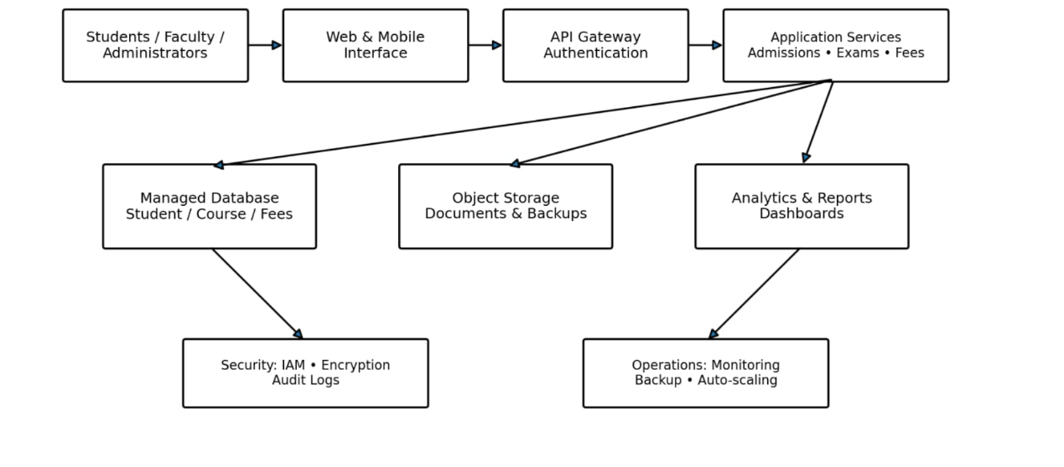
Users Across Four Campuses
Students • Faculty • Administrators
Secure Access Layer
HTTPS • DNS • Web Application Firewall • Identity Management
Load Balancer
Distributes requests across healthy application instances
Web Layer
Student portal, staff portal, user interfaces
Application Layer
Student records, examinations, library, email integrations
Database Services
Student records, courses, results
Storage Services
Documents, reports, backups
Monitoring and Disaster Recovery
Logs • Alerts • Protected backups • Recovery environment
Figure 2: Proposed Cloud Architecture for the University
8.2 Architecture Components
1. User Access Layer
Students, faculty, and administrators access university services through web browsers or mobile applications. HTTPS protects information while it travels between clients and servers.
2. Security Layer
The security layer manages identity verification, authorization, network protection, and access restrictions. Administrative accounts should use stronger authentication controls.
3. Load Balancer
The load balancer distributes incoming requests across healthy application instances. This helps prevent individual instances from becoming overloaded.
4. Web Layer
The web layer provides the user interface for the student portal, staff portal, and other university applications.
5. Application Layer
The application layer processes attendance, course registration, examination results, library operations, and other business functions.
6. Database Layer
The database layer stores structured information. Database permissions should restrict access to authorized users and application services.
7. Storage Layer
The storage layer maintains documents, reports, and other files. Backup copies should be protected against unauthorized access and accidental deletion.
8. Monitoring and Recovery Layer
Monitoring identifies availability and performance problems. Backup and disaster recovery systems help restore services after failures.
8.3 Deployment and Service Models
A hybrid-cloud deployment is recommended as a starting point if the university needs to retain selected systems internally. Public cloud services can support applications that require flexible capacity.
The service models should be selected according to the application:
- IaaS for suitable legacy applications.
- PaaS for new APIs and web applications.
- SaaS for managed email and other suitable applications.
- DBaaS and DRaaS for managed database and recovery capabilities.
8.4 Scalability
The application layer should support horizontal scaling by adding instances when traffic increases. Scaling decisions should consider CPU usage, memory, request rates, response times, and error rates.
Database capacity must also be monitored because increasing the number of application instances does not automatically resolve database bottlenecks.
8.5 Security
The university should implement role-based access control, multi-factor authentication for sensitive accounts, encrypted communications, secure API access, network segmentation, audit logging, and regular security updates.
Sensitive student information must be accessible only to authorized users.
8.6 Availability and Disaster Recovery
Critical applications should avoid unnecessary single points of failure. Redundant application instances, suitable database recovery mechanisms, protected backups, and a separate recovery environment can improve resilience.
The university should test performance, backup restoration, and disaster recovery procedures regularly.
Conclusion: The proposed architecture provides a foundation for secure multi-campus access, scalable applications, centralized management, and improved recovery capabilities.
TASK 9: Hands-On Cloud Application Implementation
9.1 Objective
The objective is to develop and test a simple REST API that demonstrates how a university application can provide student information over HTTP.
The prototype uses Python and Flask. It can run locally or in a container and can later be deployed to a compatible cloud platform.
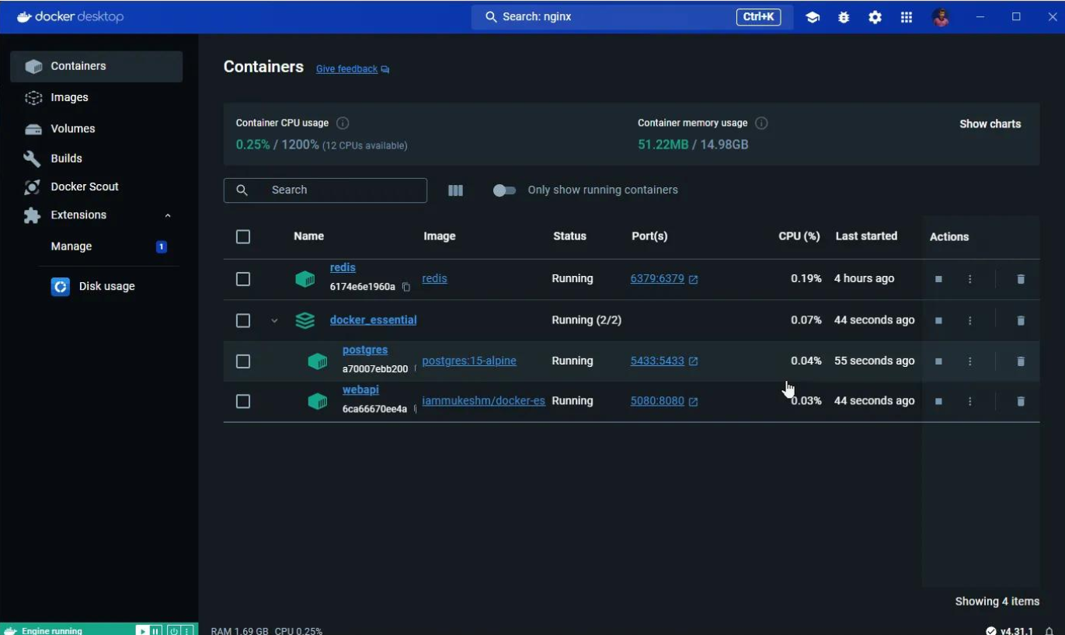
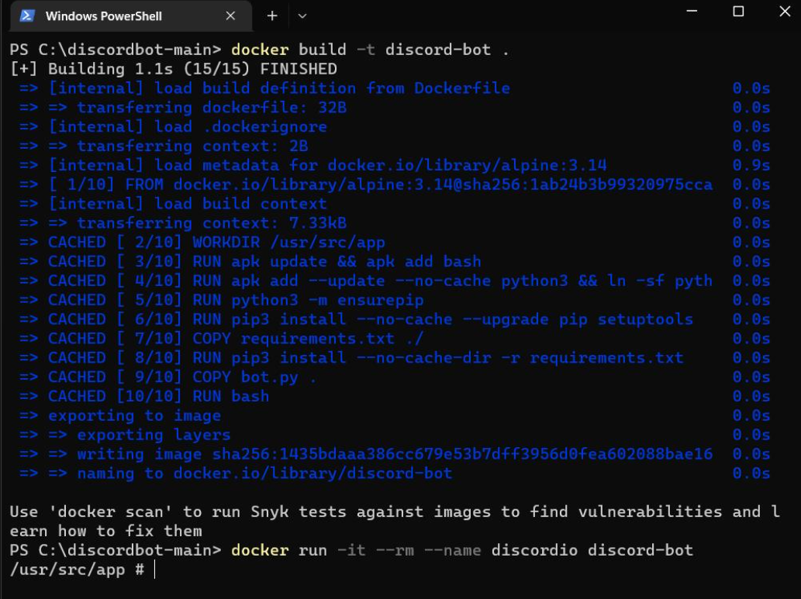
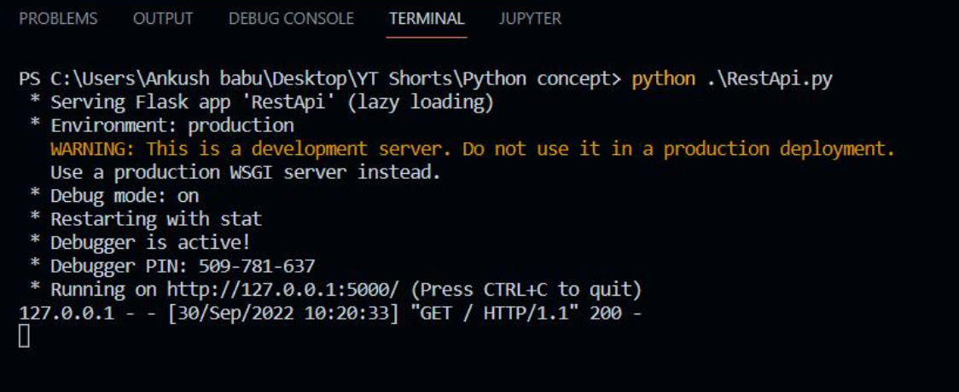
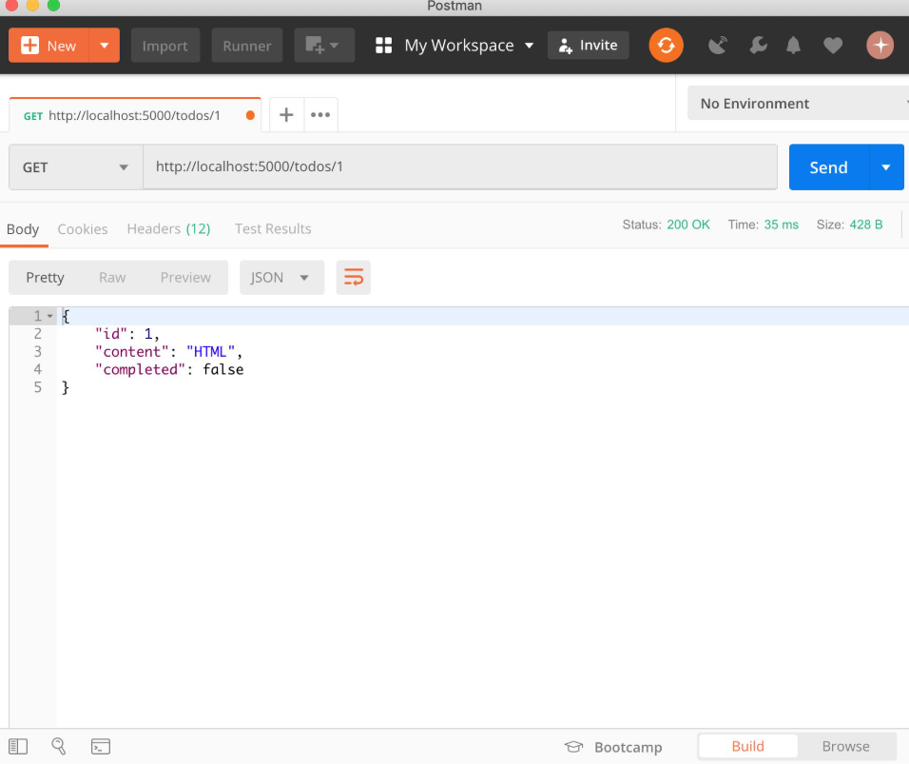
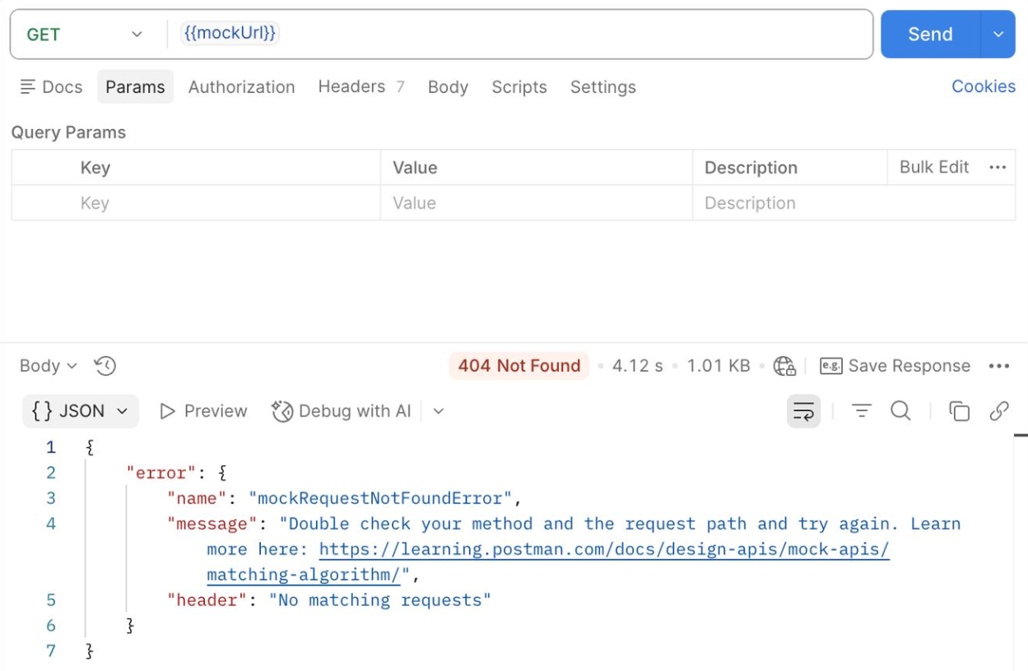
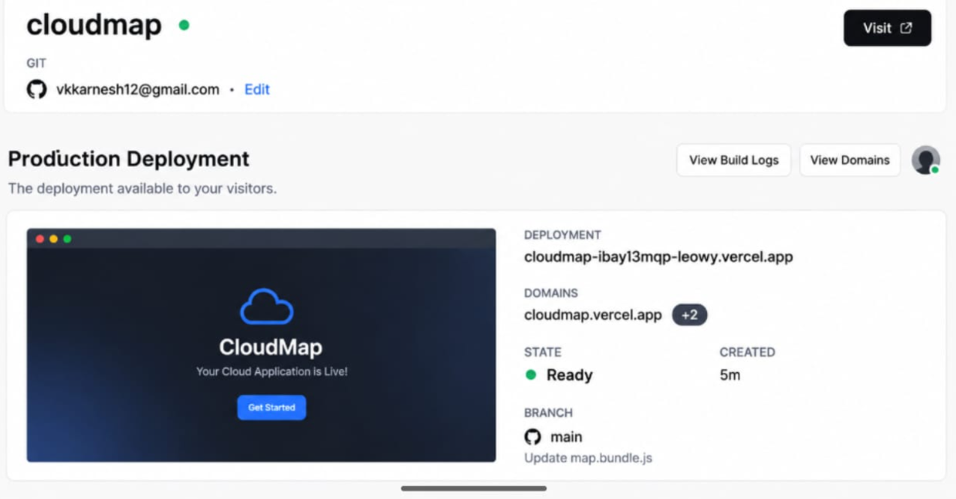
9.2 Project Structure
Create a project folder named university-cloud-api.
university-cloud-api/
├── app.py
├── requirements.txt
└── Dockerfile
9.3 Flask Application
Create a file named app.py and add the following code.
from flask import Flask, jsonifyapp = Flask(__name__)students = { "STU1001": { "student_id": "STU1001", "name": "Student One", "department": "AI and Data Science" }, "STU1002": { "student_id": "STU1002", "name": "Student Two", "department": "Computer Science" }}@app.route("/")def home(): return jsonify({ "message": "University Cloud API", "status": "running" })@app.route("/health")def health(): return jsonify({ "status": "healthy" })@app.route("/api/v1/students/<student_id>")def get_student(student_id): student = students.get(student_id) if student is None: return jsonify({
9.4 Dependency File
Create requirements.txt.
Flask>=3.1,<4.0
9.5 Run the Application
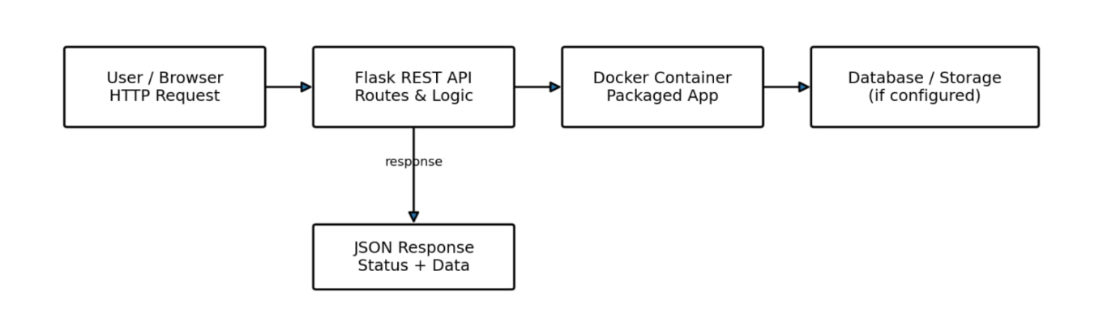
Open a terminal in the project directory.
Create a Python virtual environment:
python -m venv venv
Activate it in Windows PowerShell:
.\venv\Scripts\Activate.ps1
Install the dependency:
python -m pip install -r requirements.txt
Run the application:
python app.py
Open these addresses in a browser:
http://127.0.0.1:5000/
http://127.0.0.1:5000/health
http://127.0.0.1:5000/api/v1/students/STU1001
9.6 Expected API Responses
The home endpoint should return:
{
"message": "University Cloud API",
"status": "running"
}
The health endpoint should return:
{
"status": "healthy"
}
The student endpoint should return a record similar to:
{
"department": "AI and Data Science",
"name": "Student One",
"student_id": "STU1001"
}
These are expected outputs. The actual responses should be checked after executing the application.
9.7 Docker Configuration
Create a file named Dockerfile.
FROM python:3.12-slim

WORKDIR /app

COPY requirements.txt .

RUN pip install --no-cache-dir -r requirements.txt

COPY app.py .

EXPOSE 5000

CMD ["python", "app.py"]
Build the Docker image:
docker build -t university-cloud-api .
Run the container:
docker run --rm -p 5000:5000 university-cloud-api
Open http://127.0.0.1:5000/ to test the application.
9.8 Test Cases
Test case | Request | Expected result
Home endpoint | GET / | HTTP 200 and API status
Health endpoint | GET /health | HTTP 200 and healthy status
Existing student | GET /api/v1/students/STU1001 | HTTP 200 and student information
Unknown student | GET /api/v1/students/STU9999 | HTTP 404 and error message
9.9 Cloud Deployment
The application can be deployed to a compatible PaaS or container-hosting platform.
The deployment process consists of uploading the source code to a Git repository, creating an application service, configuring the build and start commands, setting the required port, and deploying the application.
After deployment, the public URL should be tested using a browser or API testing tool. Application logs should also be checked to confirm that the service is running correctly.
9.10 Limitations and Improvements
This prototype stores sample data in application memory. It does not provide persistent database storage, authentication, authorization, or production-level security.
A production version should include a database, secure user authentication, role-based access control, input validation, monitoring, HTTPS, backups, automated tests, and recovery procedures.
Conclusion: The Flask application demonstrates the basic structure of a cloud-ready API. Actual execution, API testing, container verification, and deployment testing are necessary to validate the implementation.
TASK 10: Evaluate and Recommend the Final Cloud Solution
10.1 Comparison of Hosting Approaches
Factor | On-premises | IaaS | PaaS/SaaS
Infrastructure ownership | University | Cloud provider owns physical infrastructure | Cloud provider manages the platform or application infrastructure
Initial investment | High hardware expenditure | Generally lower initial infrastructure investment | Generally lower infrastructure investment
Maintenance | Managed by university staff | Shared responsibility, with more customer management | Provider manages more infrastructure and application maintenance
Control | High | High over guest operating systems and applications | Depends on the service
Scalability | Limited by installed hardware | Can scale through provisioning and automation | Depends on platform and service capabilities
Migration | Existing environment | Often suitable for legacy applications | May require application changes or data migration
Operational effort | High infrastructure-management effort | Moderate to high | Generally lower
Vendor dependence | Hardware and software suppliers | Depends on cloud services used | Depends on application and platform portability
10.2 Three-Year Cost Analysis
The following figures are illustrative planning assumptions in Indian rupees. They are not verified cloud-provider quotations. Actual costs depend on workload, storage, licensing, network traffic, backup requirements, selected services, and regional pricing.
All amounts are in ₹ lakh.
Cost component | On-premises | IaaS | PaaS/SaaS
Initial hardware or migration cost | 18 | 3 | 4
Annual hosting or service cost | 6 | 7 | 6
Annual administration or management | 4 | 2.5 | 1.5
Annual backup and disaster recovery | 2 | 1.5 | 1.5
Total annual recurring cost | 12 | 11 | 9
Three-year total | 54 | 36 | 31
On-premises calculation
\[ 18+(12\times3)=\boxed{₹54\text{ lakh}} \]
IaaS calculation
\[ 3+(11\times3)=\boxed{₹36\text{ lakh}} \]
PaaS/SaaS calculation
\[ 4+(9\times3)=\boxed{₹31\text{ lakh}} \]
Under these assumptions, PaaS/SaaS has the lowest estimated three-year cost. The university must confirm whether its legacy applications can be supported by these services and whether the estimates include all required capabilities.
10.3 Major Migration Risks and Mitigation
Risk | Impact | Mitigation
Data loss | Important student or examination records may be lost. | Maintain verified backups and validate migrated data.
Application incompatibility | Legacy systems may fail in the new environment. | Perform dependency analysis and pilot migration testing.
Downtime | University services may become temporarily unavailable. | Use phased migration, rollback procedures, and maintenance planning.
Security breaches | Confidential student information may be exposed. | Apply encryption, least-privilege access, and security testing.
Cost overruns | Cloud expenditure may exceed the budget. | Use budgets, alerts, usage monitoring, and resource optimization.
Vendor lock-in | Moving applications to another provider may be difficult. | Assess portability and maintain documented interfaces.
Skill shortages | Staff may struggle to operate the new environment. | Provide training and document operational procedures.
10.4 Phased Migration Roadmap
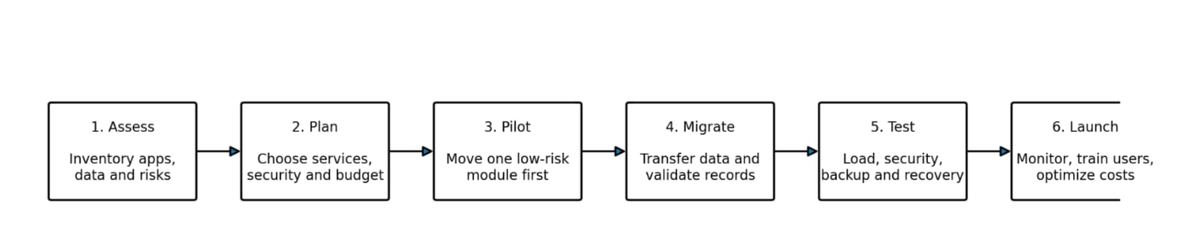
Phase 1: Assessment
Inventory all twelve servers and identify application dependencies, database requirements, peak workloads, data sensitivity, and recovery needs.
Phase 2: Infrastructure Preparation
Select suitable cloud services and establish networking, identity management, monitoring, security controls, and backup arrangements.
Phase 3: Pilot Migration
Migrate a lower-risk application to validate compatibility, security, performance, and recovery procedures.
Phase 4: Core Application Migration
Migrate suitable legacy applications to IaaS and move compatible services to PaaS or SaaS. Validate application integrations and data integrity.
Phase 5: Testing and Optimization
Conduct performance tests, security assessments, backup restoration tests, and cost reviews. Adjust capacity according to actual demand.
Phase 6: Full Operation
Expand the migrated services gradually, monitor availability, review expenditure, and maintain documented recovery procedures.
10.5 Final Recommendation
The university should adopt a phased cloud migration strategy using a combination of IaaS, PaaS, and SaaS.
IaaS can support legacy applications that need operating-system control. PaaS can support new APIs and web applications, while SaaS can reduce maintenance for suitable services such as email and learning management.
The university should prioritize data security, reliable service availability, cost control, and disaster recovery. The final provider and service selection should be based on measured workloads, application compatibility, security requirements, and detailed quotations.
TASK 11: Re-evaluate and Adapt the Cloud Architecture for the New Requirements
11.1 Introduction
The university's requirements have changed. It must now support a mobile application, provide student-record and fee-payment services to 40 affiliated colleges, handle ten times the current peak workload, achieve 99.9% availability, and remain within a limited operating budget.
These changes require improvements to the original cloud architecture, especially API management, tenant isolation, application capacity, payment security, and disaster recovery.
Decision: Modify the original architecture.
The existing cloud migration strategy remains useful, but the architecture must be strengthened to meet the new requirements.
11.2 Impact of the New Requirements
Mobile Application
The university must provide secure APIs that allow mobile users to access authorized services. Authentication, authorization, input validation, and appropriate session management are essential.
Forty Affiliated Colleges
The system must distinguish each college and ensure that users access only the records they are authorized to view or manage.
Tenfold Peak Workload
The application and database layers must be tested for the expected traffic. Scaling application instances alone may not solve database, storage, or network bottlenecks.
99.9% Availability
The architecture requires suitable redundancy, health monitoring, backup procedures, and tested recovery mechanisms.
Limited Operating Budget
The university should use capacity planning, automated scaling, service monitoring, and cost controls to avoid unnecessary infrastructure expenditure.
11.3 Revised Architecture
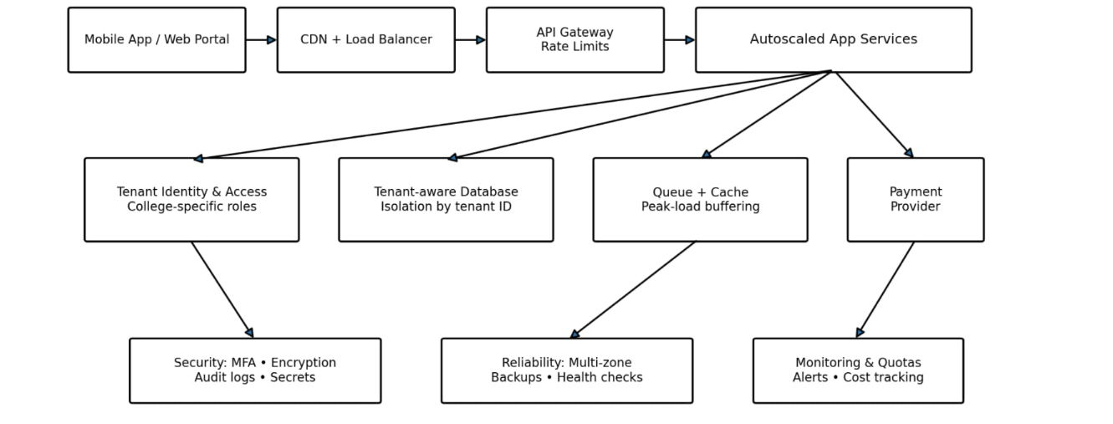
Students, Staff and 40 Affiliated Colleges
Web portal • Mobile application • College portals
Secure API Gateway
HTTPS • Authentication • Authorization • Rate limiting • Request validation
Load Balancing and Autoscaling
Distributes requests across healthy application instances
Student Services
Profiles, attendance, courses, examination results
Payment Services
Fee requests, payment gateway, transaction status
Database and Storage Layer
Tenant-aware access • Transaction integrity • Encryption • Backups
Monitoring and Recovery Environment
Health checks • Alerts • Protected backups • Recovery deployment
Figure 3: Revised Cloud Architecture for Mobile Access and Affiliated Colleges
11.4 Capacity Planning
Let the measured current peak request rate be \(P\) requests per second.
The expected future peak is:
\[ P_{\text{future}}=10P \]
For example, if the measured current peak is 200 requests per second:
\[ P_{\text{future}}=10\times200 \]
\[ \boxed{P_{\text{future}}=2{,}000\text{ requests/second}} \]
This is an illustrative example. The university must measure its actual peak request rate before selecting production capacity.
Load testing should evaluate API response times, error rates, CPU and memory utilization, database performance, network capacity, and payment processing. The system should also be tested when an application instance or other component fails.
11.5 Availability Calculation
The required availability is 99.9%.
The corresponding unavailability is:
\[ 100\%-99.9\%=0.1\% \]
Assuming a 365-day year:
\[ 365\times24=8{,}760\text{ hours} \]
Annual downtime allowance:
\[ 8{,}760\times0.001=8.76\text{ hours} \]
Therefore, the theoretical annual downtime allowance is:
\[ \boxed{8.76\text{ hours per year}} \]
This calculation assumes that availability is measured over the entire year. The university must define its measurement method and whether planned maintenance is included.
Multi-zone deployment, redundant application instances, health checks, and tested recovery procedures can help achieve the target. Actual availability must be verified through operational measurements.
11.6 Multi-Tenant Security
Multi-tenancy allows multiple affiliated colleges to use the same application while keeping their data and permissions logically separated.
The university should implement the following controls:
- Assign a unique tenant identifier to each affiliated college.
- Authenticate users and associate them with approved colleges.
- Enforce tenant-level authorization for every relevant request.
- Apply tenant restrictions in application logic and database access.
- Prevent users from accessing other colleges' records by changing request parameters.
- Maintain audit logs for student-record access and administrative actions.
- Encrypt sensitive information in transit and at rest.
- Apply rate limits to protect shared infrastructure.
- Test cross-tenant access restrictions.
- Provide secure access revocation and backup procedures.
The university can use a shared database with strong tenant separation or separate databases for selected colleges. The decision should consider security, cost, operational complexity, and institutional requirements.
11.7 Secure Fee-Payment Processing
The payment system must ensure that payment requests and transaction records remain accurate and protected.
The revised design should:
- Integrate with an approved payment gateway.
- Verify transaction outcomes using trusted gateway responses.
- Use idempotency controls to prevent duplicate payment processing.
- Store transaction references and appropriate audit records.
- Restrict access to financial information.
- Reconcile payment records against gateway reports.
- Avoid storing sensitive payment information unnecessarily.
- Provide a documented process for interrupted or uncertain transactions.
11.8 Budget and Cost Evaluation
The following figures are illustrative planning assumptions rather than provider quotations.
Assume that the revised design requires an initial setup and migration cost of ₹5 lakh, with annual hosting costs of ₹9 lakh, management costs of ₹2 lakh, and backup and disaster recovery costs of ₹2 lakh.
Annual recurring cost:
\[ 9+2+2=₹13\text{ lakh} \]
Three-year total:
\[ 5+(13\times3)=\boxed{₹44\text{ lakh}} \]
Compared with the earlier illustrative PaaS/SaaS estimate of ₹31 lakh, this revised example costs ₹13 lakh more over three years.
The additional expenditure may be justified if it provides the required capacity, security, and recovery capabilities. The final budget must be confirmed through workload testing and provider quotations.
Cost-control measures include automated scaling, usage monitoring, spending alerts, resource cleanup, and regular review of database, storage, and data-transfer costs.
11.9 Revised Implementation Plan
Phase 1: Requirements Assessment
Measure the current peak workload, identify data sensitivity, define college access requirements, and establish recovery objectives.
Phase 2: API and Security Implementation
Configure the API gateway, authentication, authorization, tenant separation, audit logging, and payment integration.
Phase 3: Capacity and Availability Improvements
Configure load balancing, autoscaling, database capacity, monitoring, and suitable caching.
Phase 4: Validation
Perform load testing, security testing, cross-tenant access testing, payment verification, and disaster recovery exercises.
Phase 5: Pilot Deployment
Start with a limited group of users or affiliated colleges. Validate performance and security before expanding access.
Phase 6: Full Deployment
Expand access gradually, monitor service availability, review cloud expenditure, and test recovery procedures regularly.
11.10 Final Recommendation
The university should modify its original architecture rather than retain it unchanged or undertake an unnecessary complete redesign.
The revised design should include a secure API gateway, tenant-aware access control, load balancing, autoscaling, protected database services, secure payment processing, monitoring, and a tested disaster recovery environment.
Before full deployment, the university must validate the tenfold peak workload through load testing and confirm that the 99.9% availability objective can be met within the approved budget.
This approach provides a practical foundation for secure mobile access, integration with 40 affiliated colleges, improved scalability, and reliable university services.

